Experiment - 04
Data Modelling and Form Design for a Business Application in Zoho Creator
Rathna velu P
241401078 B.Tech CSBS
AIM
To design and build a functional “Patient Appointment & Scheduling Management” application in Zoho Creator that demonstrates the correct usage of all thirteen Basic Fields available in the Form Builder — Name, Email, Address, Phone, Single Line, Multi Line, Number, Date, Time, Drop Down, Radio, Multi Select, and Checkbox — and to model the underlying data structure of a real healthcare appointment-booking workflow through a properly sectioned form and an auto-generated report view.
PROCEDURE
1. Data Model Design
Before building the form, the appointment data requirement was analysed and organised into four logical sections that map to the stages of a patient's appointment journey: Patient Details, Contact Details, Medical Details, and Scheduling & Consent. Every field submitted through the form flows into a single report, Appointment_Booking_Report, which the front desk and doctors use to review appointment requests. The resulting data model is shown below.
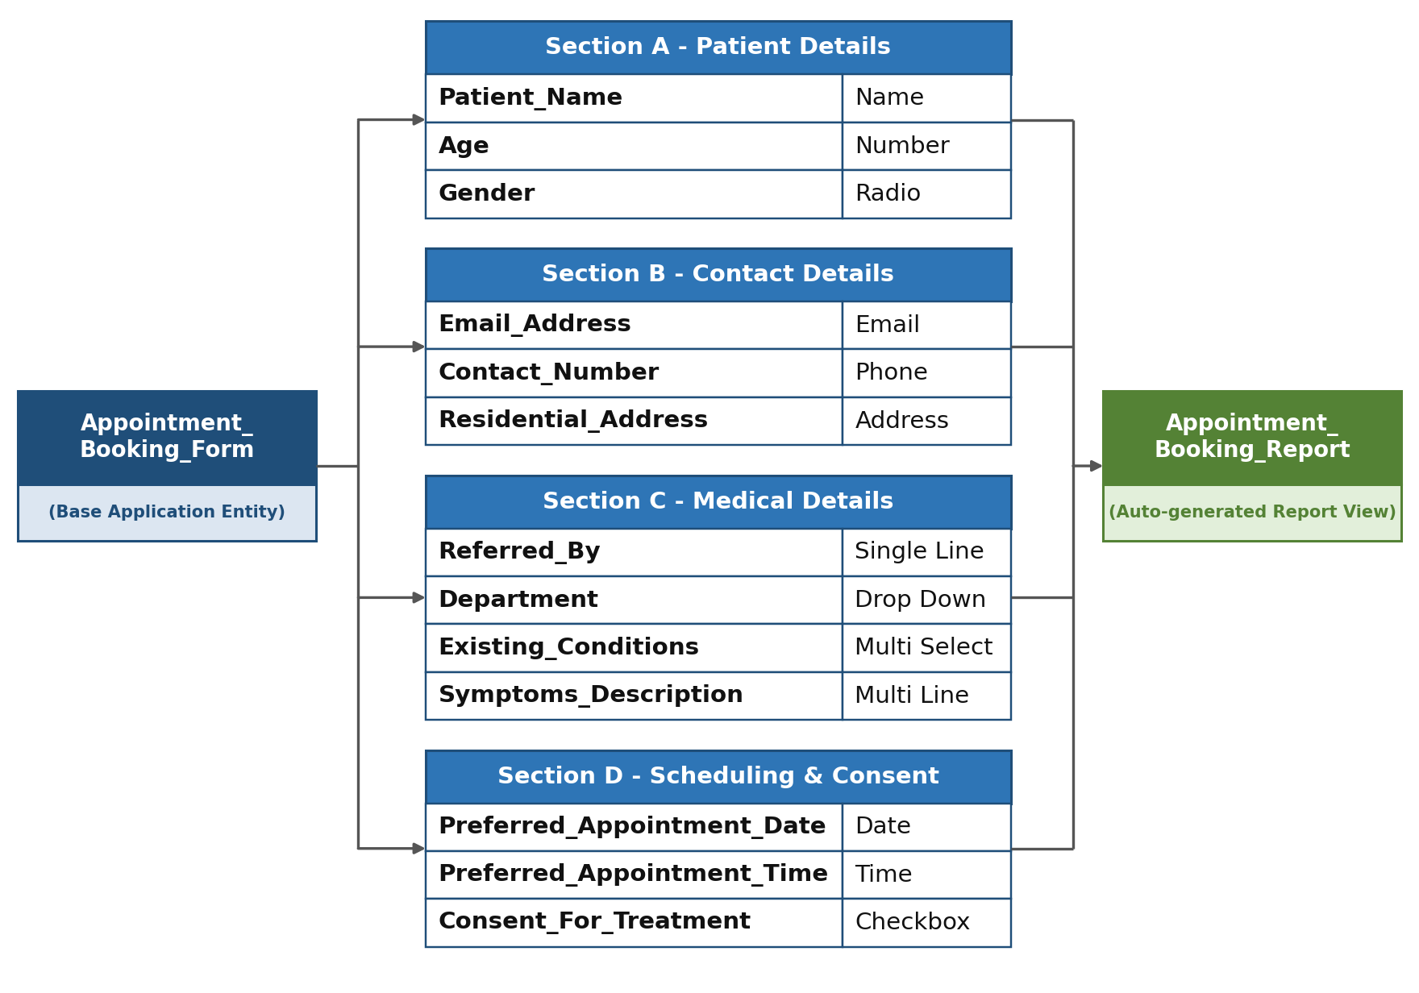
Fig 1. Data Model — Appointment_Booking_Form and its sectioned fields feeding Appointment_Booking_Report
2. Application and Form Creation
1. Logged into Zoho Creator and selected Create New Application → Create from Scratch.
2. Named the application “Patient Appointment & Scheduling Management” and confirmed creation, which opened the blank application workspace.
3. Created a new form inside the application and named it Appointment_Booking_Form.
4. Created the linked list report Appointment_Booking_Report to display submitted appointment requests.
3. Drag-and-Drop of Basic Fields
In the Form Builder, the Basic Fields palette was used to place each required field on the form. Each field was configured through its Field Properties panel for the required field name, label, options, and validation.
Basic Field | Field Name Set | Drag-and-Drop Configuration
Name | Patient_Name | Placed in Patient Details; uses First Name and Last Name sub-fields.
Email | Email_Address | Placed in Contact Details; built-in email format validation enabled.
Address | Residential_Address | Placed in Contact Details; captures residential address details.
Phone | Contact_Number | Placed in Contact Details; configured for Indian (+91) phone format.
Single Line | Referred_By | Placed in Medical Details; short free-text entry for referring doctor/source.
Multi Line | Symptoms_Description | Placed in Medical Details; expanded text area for symptoms/reason for visit.
Number | Age | Placed in Patient Details; validated through On Validate workflow for range 0–120.
Date | Preferred_Appointment_Date | Placed in Scheduling & Consent; past dates prevented through validation.
Time | Preferred_Appointment_Time | Placed below appointment date; used for preferred consultation time.
Drop Down | Department | Placed in Medical Details; General Medicine option configured.
Radio | Gender | Placed in Patient Details; Male, Female, and Other options added.
Multi Select | Existing_Conditions | Placed in Medical Details; multiple conditions/allergies can be selected.
Checkbox | Consent_For_Treatment | Placed in Scheduling & Consent; marked mandatory for submission.
4. Organising Fields into Sections
To keep the form patient-friendly and logically grouped, four Section fields were used and the related fields were arranged beneath the appropriate section header.
- Section A — Patient Details: Patient Name, Age, Gender.
- Section B — Contact Details: Email Address, Contact Number, Residential Address.
- Section C — Medical Details: Referred By, Department, Existing Conditions, Symptoms Description.
- Section D — Scheduling & Consent: Preferred Appointment Date, Preferred Appointment Time, I consent to examination and treatment.
5. Applying Field-Level Validations
1. Selected Patient_Name, Contact_Number, Age, Gender, Department, Preferred_Appointment_Date, and Consent_For_Treatment and enabled the Mandatory/Required setting.
2. Opened Email_Address properties and confirmed that the built-in email format validation was active.
3. Configured Contact_Number for the Indian country-code format.
4. Created an On Validate workflow named Validate_Age_Range to reject ages below 0 or above 120.
5. Created an On Validate workflow named Validate_Appointment_Date to reject dates earlier than the current date.
6. Confirmed that Consent_For_Treatment is mandatory so the form cannot be submitted without consent.
6. Preview and Deployment
1. Opened the Preview/Live Form view to verify that all four sections render in the intended order with the correct field types.
2. Submitted three sample appointment records through the form to test validations and generate report data.
3. Opened Appointment_Booking_Report and verified that submitted records appear as a list with values mapped correctly to the form fields.
4. Configured and tested an On Success workflow named Send_Appointment_Confirmation that sends an appointment request confirmation email to the Email_Address entered by the patient.
5. Tested the complete workflow and confirmed that a submitted record is stored in the report and the confirmation email is received.
OUTPUT
1. Form Builder View — All Basic Fields Placed and Sectioned
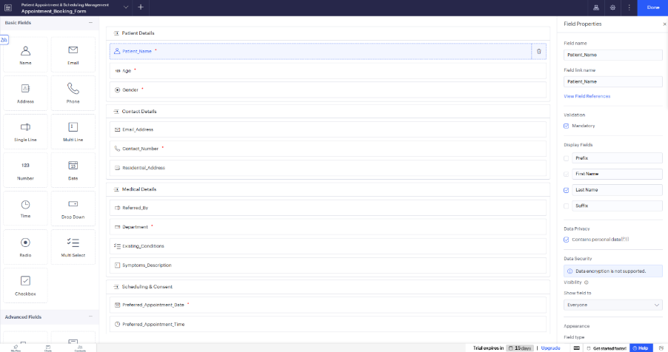
Screenshot 1 — Appointment_Booking_Form in Form Builder

2. Live Form Preview
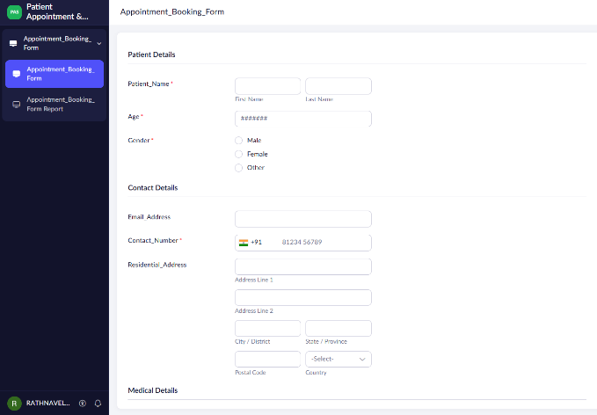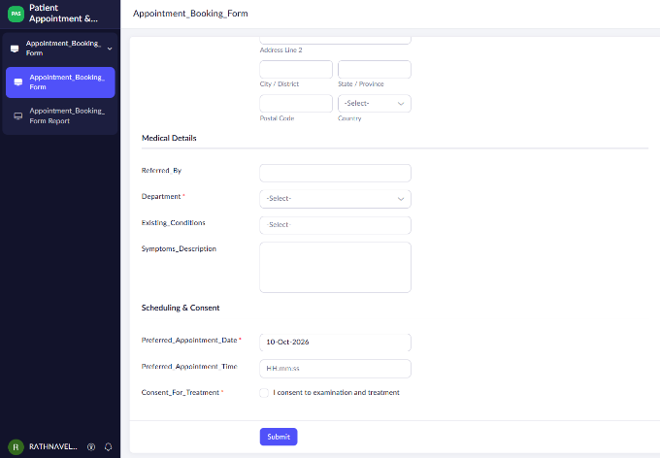
Screenshot 2 — Live Patient Appointment Booking Form Preview

3. Appointment_Booking_Report — Sample Submitted Records
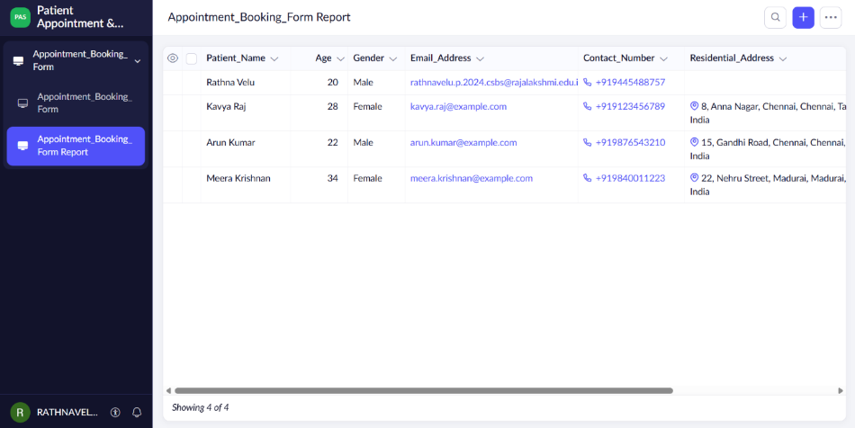
Screenshot 3 — Appointment_Booking_Report with at least three submitted records

RESULT
A Patient Appointment & Scheduling Management application was successfully designed and built in Zoho Creator using all thirteen Basic Fields. The Appointment_Booking_Report was verified to correctly capture and list patient appointment data submitted through the form.

